**QUESTION 1ST ANSWER-**

import java.util.Scanner;

public class Reverse

{

public static void main(String[] args)

{

String str1 = "SURAJ";

String d= "";

for (int i = str1.length() - 1; i >= 0; --i) {

d += str1.charAt(i);

}

char[] str=d.toCharArray();

for(int i=0;i<d.length();i++)

{

if(i==0 || str[i-1]==' ')

{

str[i]=Character.toUpperCase(str[i]);

}

else if(str[i]==' ' || str[i]=='\0')

str[i-1]=Character.toUpperCase(str[i-1]);

}

System.out.print("After Converting String is: ");

for(int i=0;i<d.length();i++)

System.out.print(str[i]);

}

}

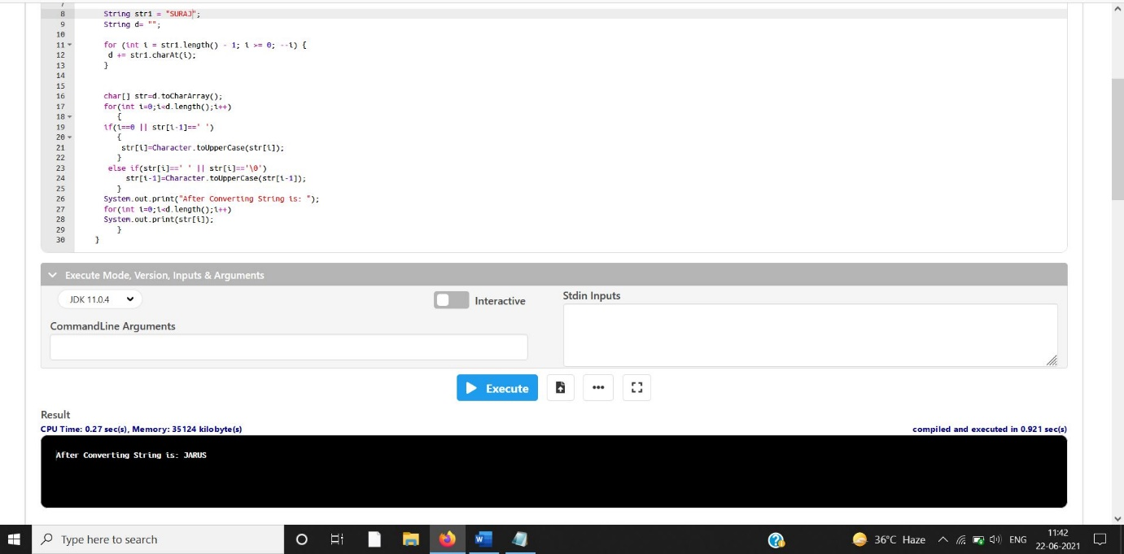

**QUESTION 2ST ANSWER-**

import java.io.*;  
import java.lang.*;  
class LessBalanceException extends Exception  
{  
 LessBalanceException(double amt)  
 {  
 System.out.println("Withdrawing "+amt+" is invlaid");  
 }  
}  
class Account  
{  
 static int count=0;  
 int accno;  
 double bal;  
 String name;  
 Account(double bal,String n,int accno)  
 {  
 System.out.println("\nNew Account opened....!!");  
 this.bal=bal;  
 count++;  
 System.out.println("Account Holder Name : " + n);  
 name=n;  
 System.out.println("Your Account Number is : "+accno);  
 this.accno=accno;  
 System.out.println("Total number of accounts : "+count);  
   
 }  
 void deposit(double amt)  
 {  
 System.out.println("Availabe Balance : "+bal);   
 bal=bal+amt;  
 System.out.println("Rs. : "+amt+" /- Created");  
 System.out.println("Balance : "+bal);  
 }  
 void withdraw(double amt) throws LessBalanceException  
 {  
 System.out.println("\nAvailabe Balance : "+bal);  
 bal-=amt;  
 if(bal<500)  
 {  
 bal+=amt;  
 throw new LessBalanceException(amt);  
 }  
 System.out.println("Rs. : "+amt+ "/-Debited");  
 System.out.println("Balacne : "+bal);  
 }  
 void balance()  
 {  
 System.out.println("\n***************Customer information****************");  
 System.out.println("============================================");  
 System.out.println("Customer Name : "+name);  
 System.out.println("Account Number : "+accno);  
 System.out.println("Balance : "+bal);  
 }  
}  
class AccountDemo  
{  
 static int i=0;  
 public static void main(String argv[]) throws IOException  
 {  
 Account ob[]=new Account[10];  
 BufferedReader br=new BufferedReader(new InputStreamReader(System.in));  
 double amt;  
 String name;  
 int ch,accno,k;  
 boolean t=false;  
 while(true)  
 {  
 System.out.println("\n******* Bank Transaction *********");  
 System.out.println("1.Open new Account\n2.Deposit");   
 System.out.println("3.Withdraw\n4.Balance\n5.Exit");  
 System.out.print("Enter your choice : ");  
 ch=Integer.parseInt(br.readLine());  
 switch(ch)  
 {  
 case 1:  
 System.out.println("Opening New Account : ");  
 System.out.print("Enter your name : ");  
 name=br.readLine();  
 System.out.print("\nEnter Account Number : ");  
 accno=Integer.parseInt(br.readLine());  
 System.out.print("\nEnter initial amount(to be >=500) : ");  
 amt=Double.parseDouble(br.readLine());  
 if(amt<500)  
 System.out.println("You cannot create an account with less than Rs.500/-");  
 else  
 {  
 ob[i]=new Account(amt,name,accno);  
 i++;  
 }  
 break;  
  
 case 2:  
 System.out.print("\nEnter Account number : ");  
 accno=Integer.parseInt(br.readLine());  
 for(k=0;k<i;k++)  
 if(accno==ob[k].accno)  
 {  
 t=true;  
 break;  
 }  
   
 if(t)  
 {  
 System.out.print("\nEnter the Amount for Deposit : ");  
 amt=Double.parseDouble(br.readLine());  
 ob[k].deposit(amt);  
 }  
 else  
 System.out.println("Invalid Account Number...!!!");  
 t=false;  
 break;  
  
 case 3:  
 System.out.print("\nEnter Account number : ");  
 accno=Integer.parseInt(br.readLine());  
 for(k=0;k<i;k++)  
 if(accno==ob[k].accno)  
 {  
 t=true;  
 break;  
 }  
   
 if(t)  
 {  
 System.out.print("\nEnter the Amount for Withdraw : ");  
 amt=Double.parseDouble(br.readLine());  
 try  
 {  
 ob[k].withdraw(amt);  
 }  
 catch(LessBalanceException e)  
 {}  
 }  
 else  
 System.out.println("Invalid Account Number...!!!");  
 t=false;  
 break;  
  
 case 4:  
 System.out.print("\nEnter Account number : ");  
 accno=Integer.parseInt(br.readLine());  
 for(k=0;k<i;k++)  
 if(accno==ob[k].accno)  
 {  
 t=true;  
 break;  
 }  
   
 if(t)  
 {  
 //System.out.println(accno +" asdfsdf " +ob[k].accno);  
 ob[k].balance();  
 }  
 else  
 System.out.println("Invalid Account Number...!!!");  
 t=false;  
 break;  
   
 case 5:  
 System.exit(1);  
 default: System.out.println("Invalid Choice !!!");  
 }  
 }  
 }  
}

